Tasks:

- Install MongoDB Compass on your system, connect to your local MongoDB server, and create a new database named spotifyDB with a collection called playlists.
use spotifyDB

- Using MongoDB Compass, import a JSON file containing at least 10 sample restaurant documents (name, cuisine, rating) into a new collection named zomatoRestaurants in your spotifyDB database.

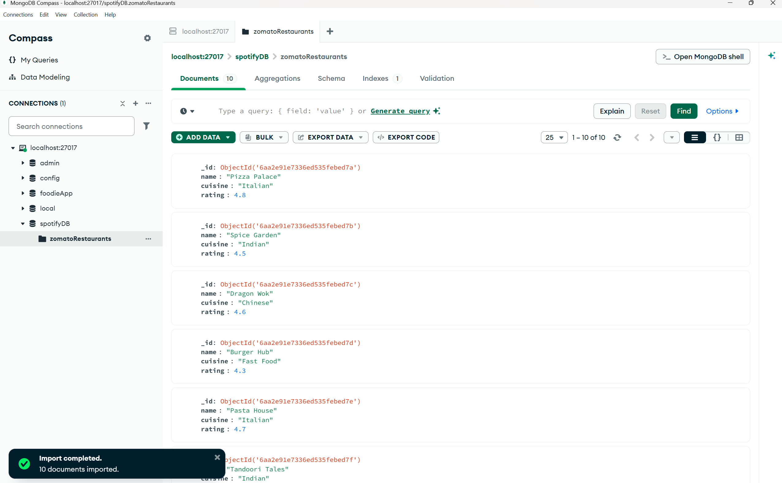

- Export:

